15 years of passion. Or was it obsession?
A lifelong interest in the Rolls-Royce Silver Ghost
By David Berthon

Ever since I learnt to drive on a 1910 Rolls-Royce Silver Ghost, I’ve been obsessed with this celebrated collector car. Okay, so that was in 1959 but my enthusiasm for Henry Royce’s masterpiece is still as strong today as it was back then.

My involvement with the Rolls-Royce Silver Ghost was in many ways a meeting of chance. My first girlfriend’s father Jack Dance had a 1938 Rolls-Royce 25/30 Saloon and a 1908 Talbot Tourer and would regularly invite me on old car rallies. The love affair with his daughter however was not long lasting and knowing that I had lost my father at a young age he kindly suggested he could introduce me to a 28-year-old enthusiast who had just finished restoring a 1920 Rolls-Royce Silver Ghost and was looking for company on club rallies.

And so started a friendship with Frank Meek, who was the proud owner of a 1920 Rolls-Royce Silver Ghost, first owned by Edmund Sheffield Willoughby Paul, the Managing Director of Schweppes Ltd. Australia and chauffer driven until 1966. Affectionately referred to as Harriet, Frank had spent several years restoring this open drive Cabriolet and over the next few years we would become good friends and he would generously take me on many rallies and eventually taught me to drive on the car when I turned 17.

Fast forward to 1988 and I received a phone call from Frank telling me he had decided to become a Priest and would be leaving to spend several years training at the Vatican. “Would I be interested in buying Harriet as we had spent so many fun times together in the car and I would prefer to sell it to you rather than anyone else.” By now, I had a young family, a mortgage, and a career firmly in tow and this was a major decision and a financial stretch, but I somehow managed it and so became the proud owner of a vintage Rolls-Royce.

Some years later a late-series 1924 Rolls-Royce Silver Ghost Hooper-bodied Landaulet would also join Harriet, but I had always hankered for one of the lighter pre-WW1 sports models that really established the Silver Ghosts reputation in competition and the marketplace. In my opinion few cars came close to the sporty London to Edinburgh Silver Ghost pre-war. Rolls-Royce would of course have significant success with them in the Austrian Alpine Trial of 1913 and later that same year take 1st and 3rd place in the Spanish Grand Prix, the only Grand Prix ever undertaken by the upper luxury car maker.

Back in 2001 I was told the last two unrestored Silver Ghost London to Edinburgh models in Australia owned by a Melbourne Doctor were available for sale. Both 1913 models, one chassis was a three-speed, the other chassis a rare four-speed. Just 188 of the sportier London to Edinburgh models were built featuring high-compression engines, a larger carburetor, two-inch taller radiators, louvred bonnets, a larger capacity fuel tank and generally sportier torpedo style coachwork.

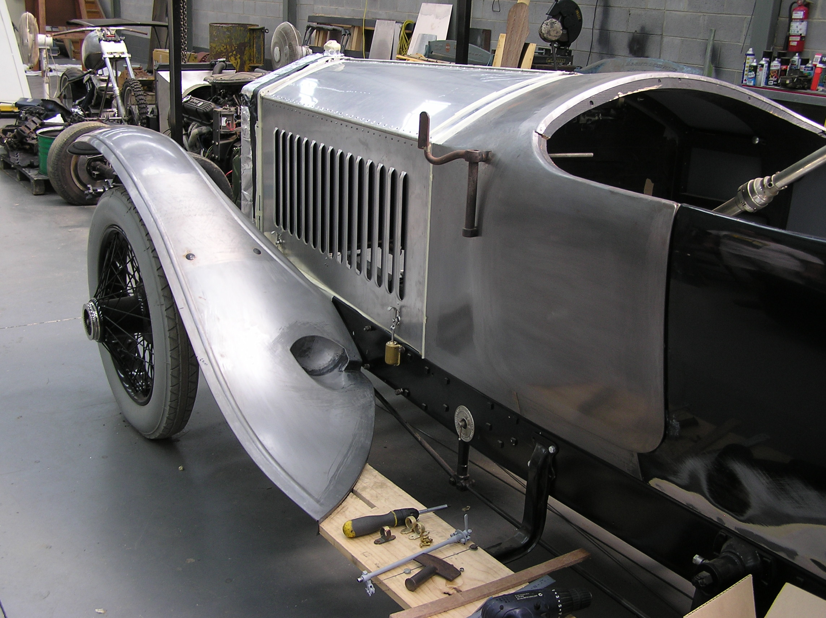

The detail on this rare Rolls-Royce is extensive and time consuming.

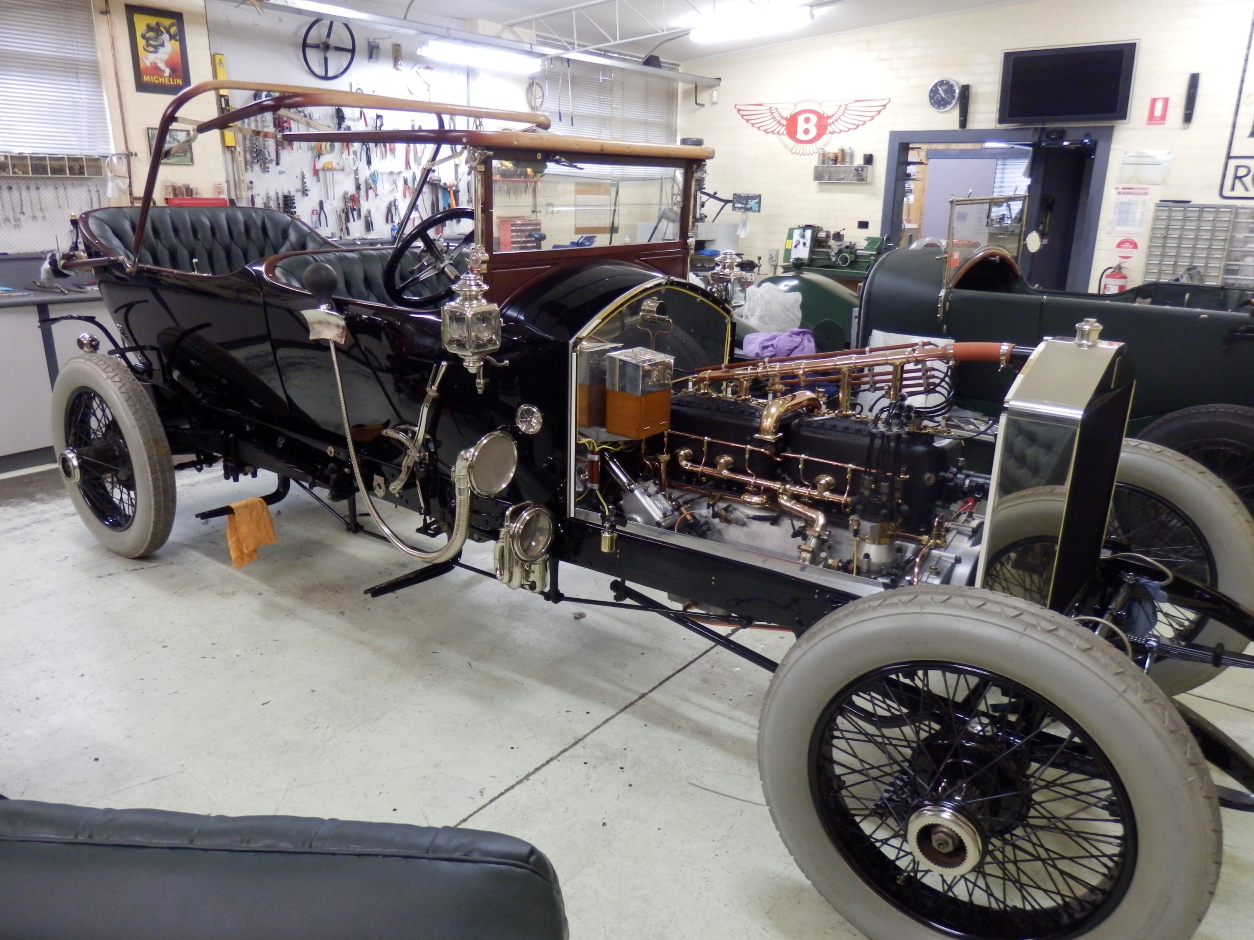

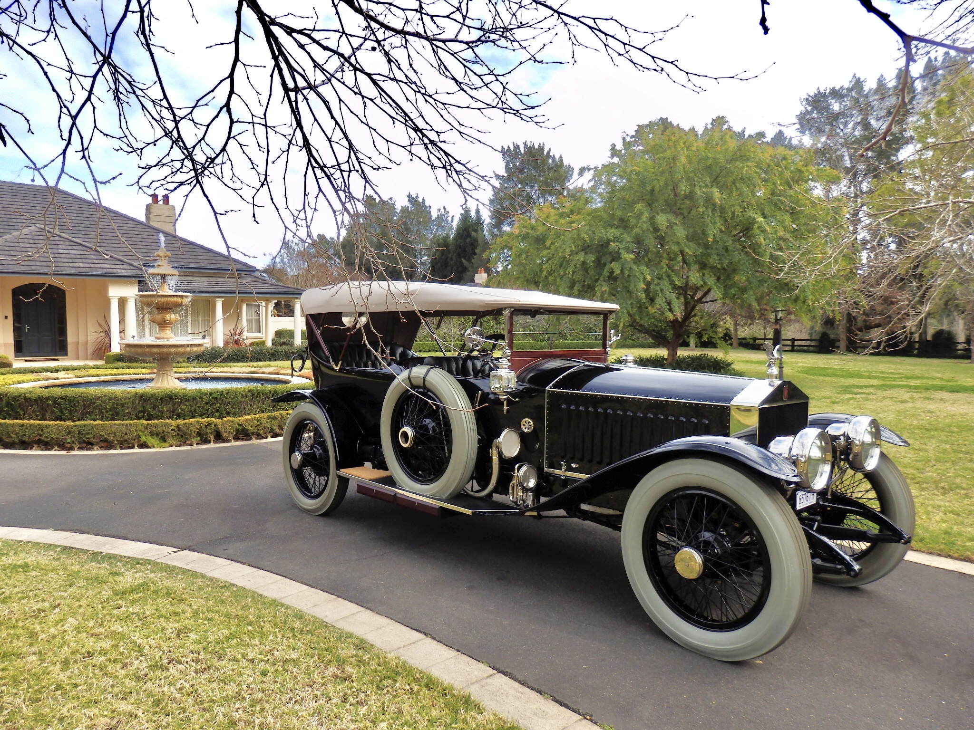

Most came with three-speed gearboxes however around 30 were fitted with four-speed gearboxes mainly out of the need for the works team cars in the 1913 Alpine Trial to have better hill climbing ratios. These four-speed L to E’s gained the added title of Colonial or Continental. Selling Harriet and trading the 1924 model I secured the four-speed, chassis 2583, which had been fitted in 1966 with a torpedo tourer body by Peels of Brisbane from a large 1913 6-litre sporting Sunbeam.

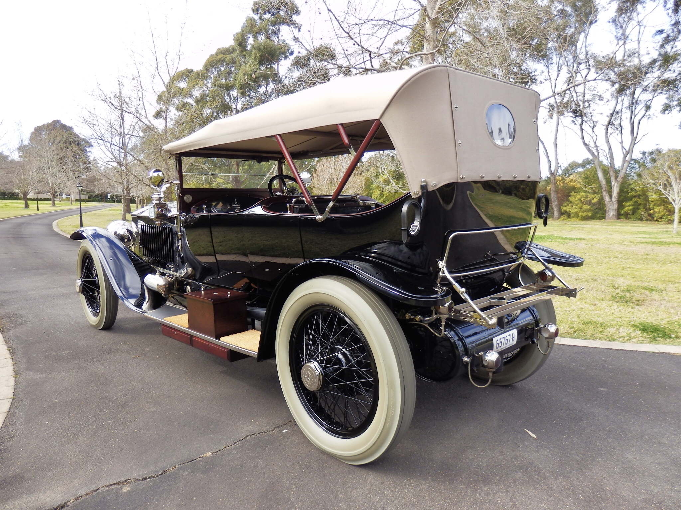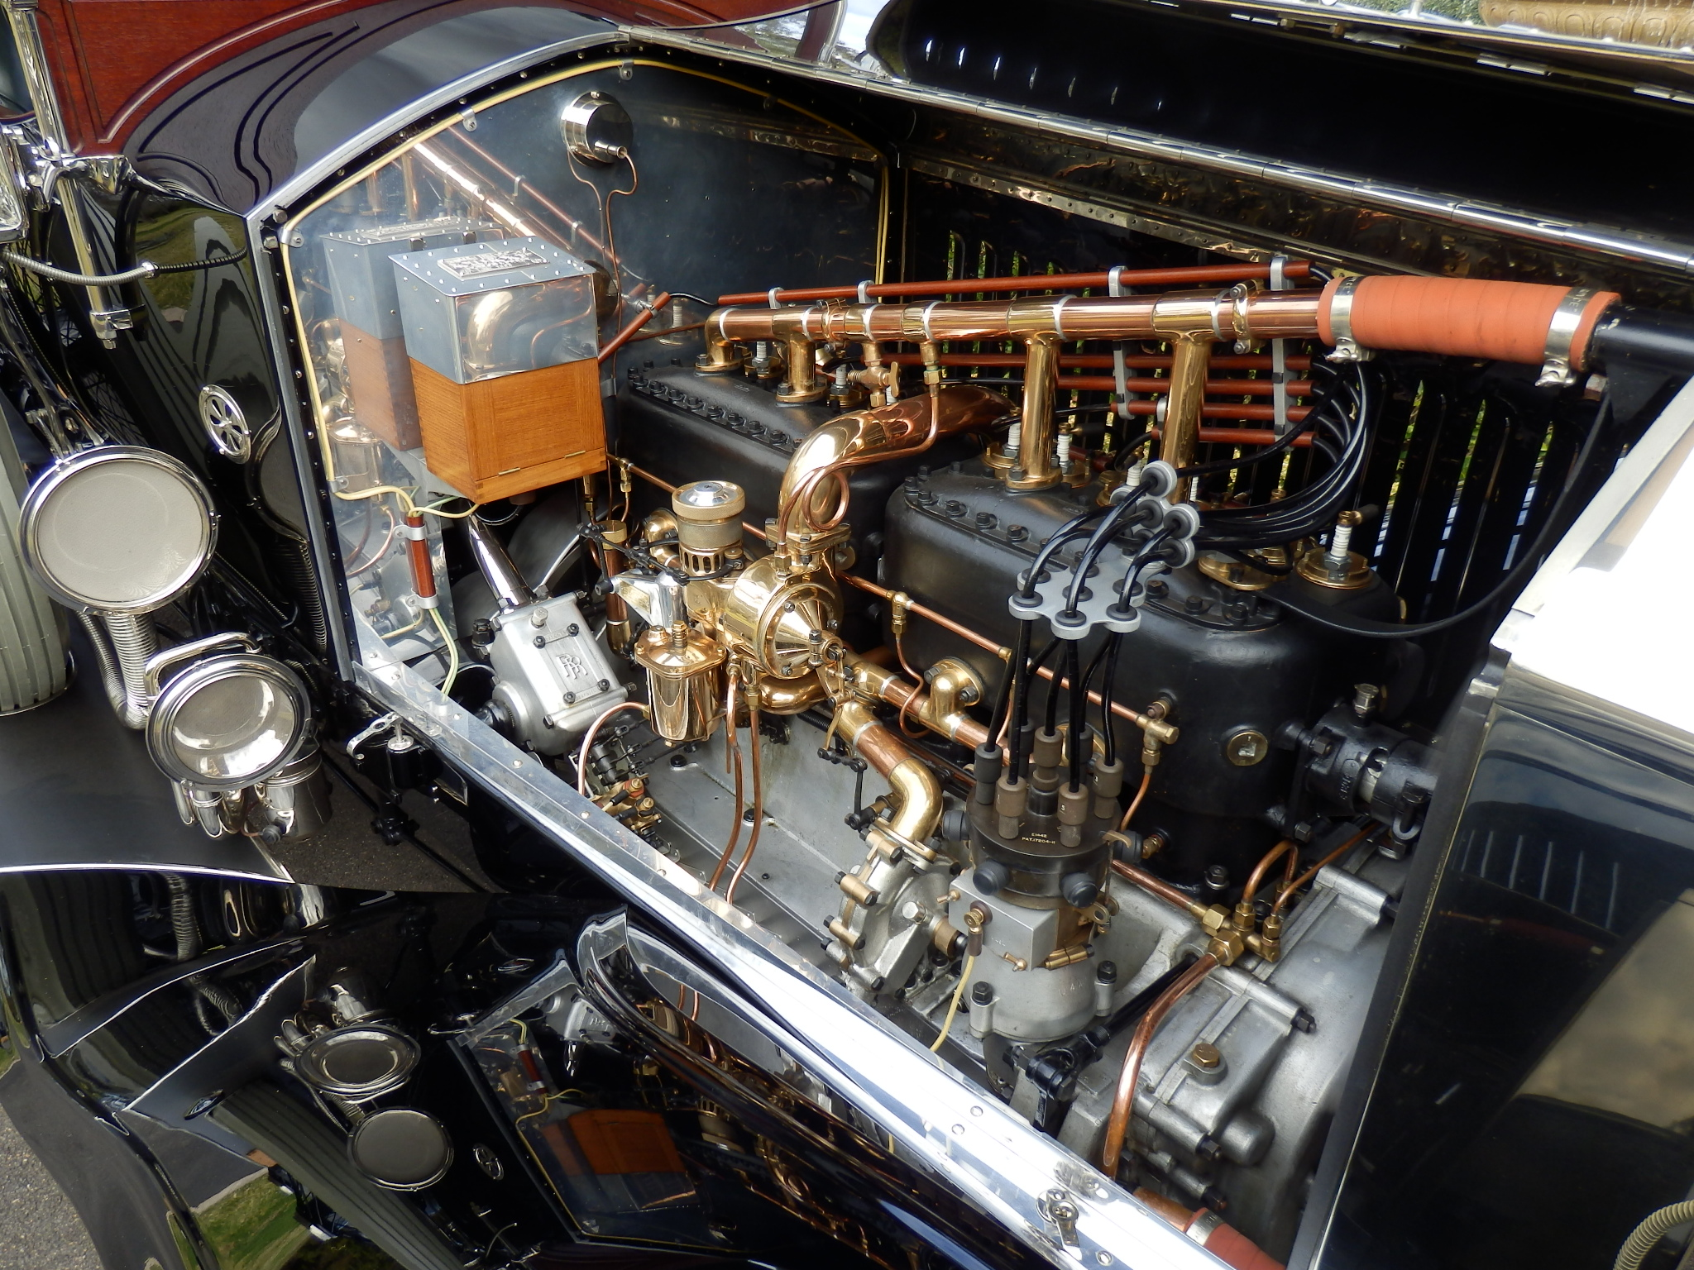

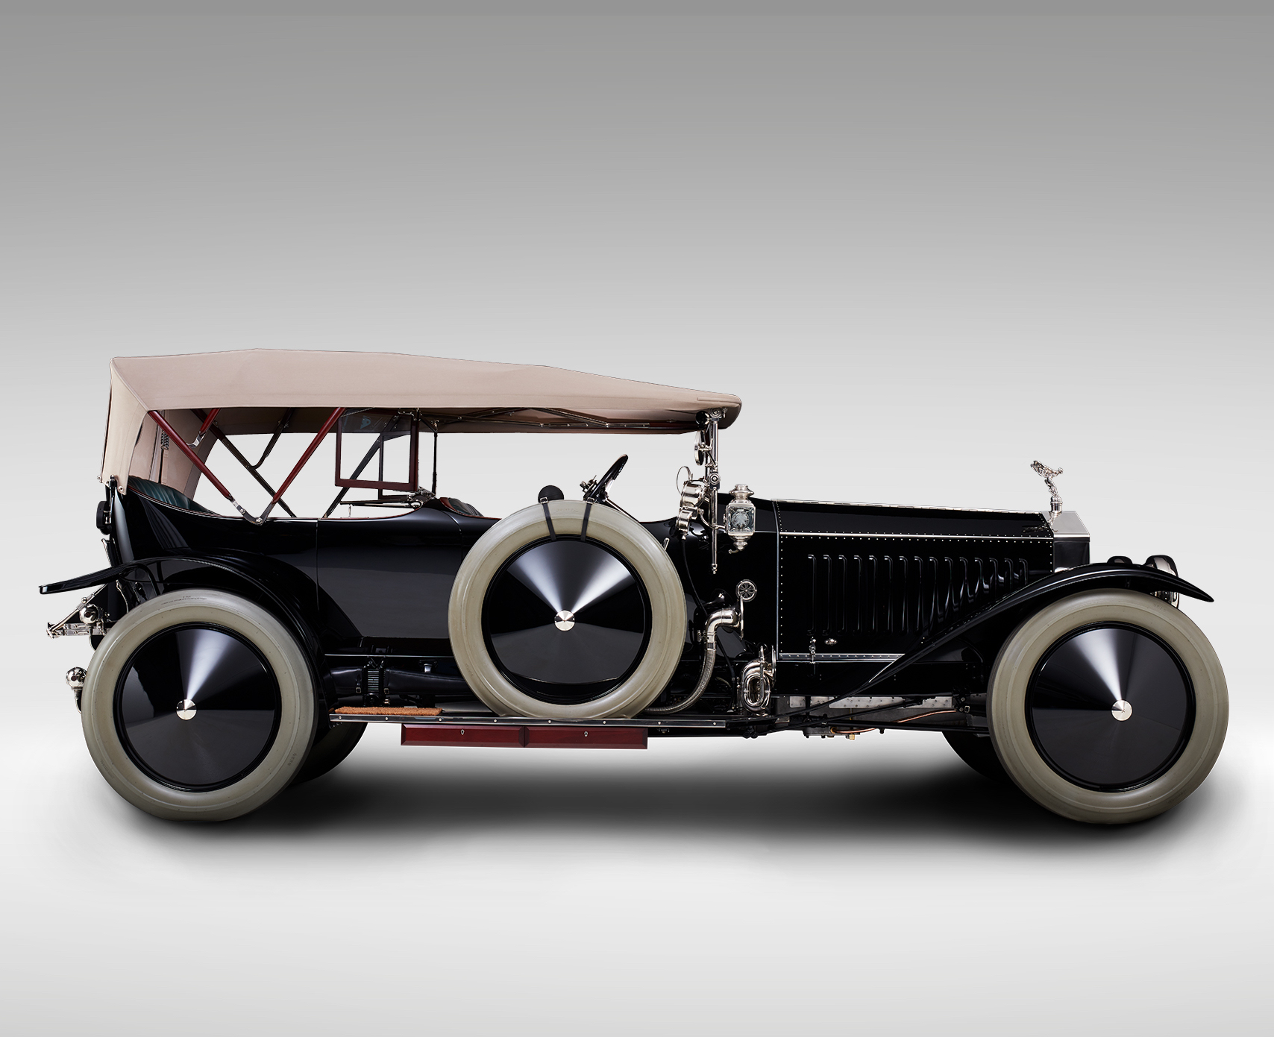

The ultimate sporting Rolls-Royce Silver Ghost – the London to Edinburgh Tourer

Interestingly, while the large Sunbeam had been delivered in Brisbane in August 1913 the Ghost had been off test at Rolls-Royce in Derby the same month and then sent to British coachbuilder Connaught for a torpedo tourer body. With war pending its new London owner quickly made the car available to the British War office for use by the armed forces. One wonders where it saw service but at one stage during the campaign its service records indicate it was in Berlin. If you provided such a vehicle for the war effort you didn’t get it back after the war, 2583 auctioned by the War Ministry at Earl’s Court on the 12th.November 1919, purchased by a doctor from Chester for 1,880 pounds.

By 1928 it had been imported to Sydney by a Randwick doctor, the new owner commissioning a local coachbuilder, Propert’s Body Works, to build a more modern tourer body. Records indicate that during the 1930’s and 40’s it would gain a number of bodies - from tourer, to saloon, then modified for use as a tow truck, then as a shooting brake, finally becoming a mourning coach for a Funeral home gaining a late 1920’s Cadillac body. Its most documented journey with this body was in 1951 when it participated in a parade in Sydney celebrating the 50th anniversary of the Federation of Parliament.

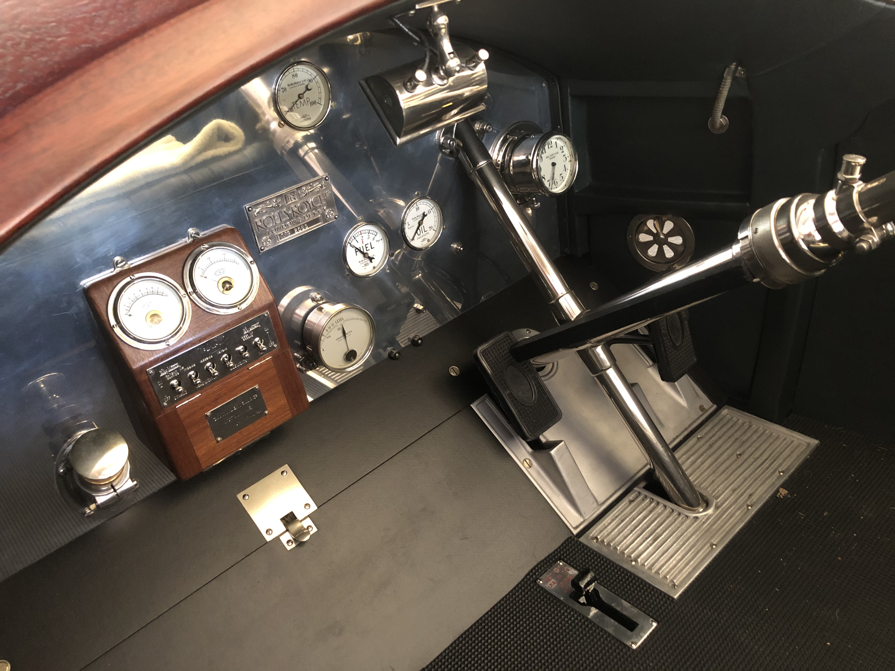

Hours of work to ensure every detail was accurate for the period

After this somewhat chequered career by the early 1960’s it had ended up in a rather dilapidated condition in a Western Sydney backyard close to a railway crossing. It was soon spotted by an enthusiast who made an offer to buy it but was quickly rejected. Some months later the same enthusiast noticed a story in the Sydney Morning Herald about a man with the same name being hit and killed by a train whilst walking across the railway crossing. Some time passed before he was able to negotiate the purchase of the Ghost from the man’s widow.

Ironically, at this time I was garaging the same enthusiast’s 41/2–litre Bentley and he took me to look at the bare Ghost chassis after he had chopped off the old Cadillac body at the local tip. Little did I think that some 40 years later I would become the owner of this rare and very complete Silver Ghost chassis? By the mid-1960’s the car had been purchased by Faris Palfreyman, a Canberra-based collector who had amassed around 26 Silver Ghosts, some complete, others in chassis form, in a wide range of condition.

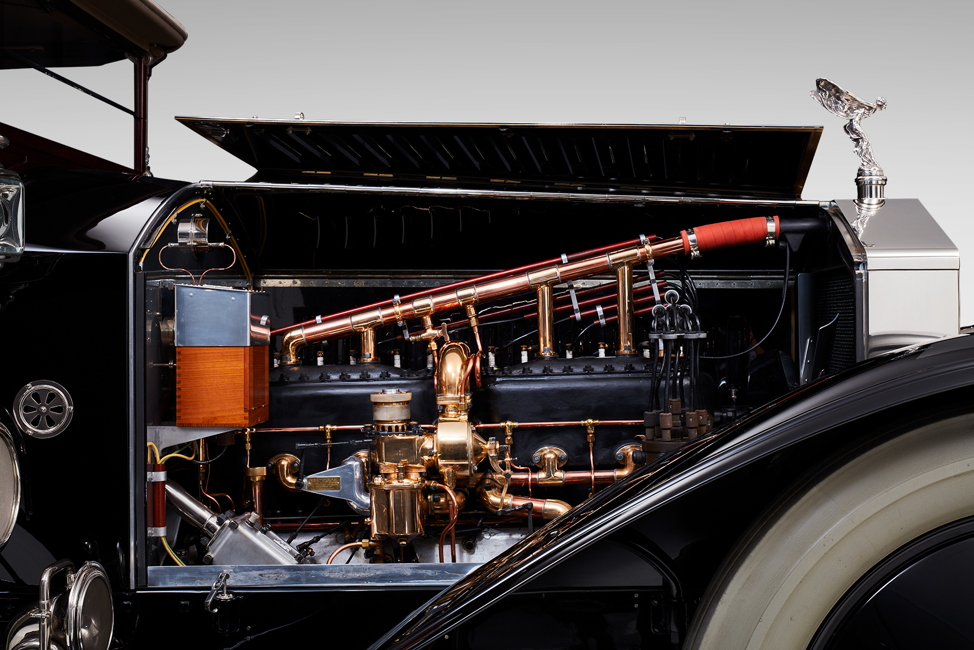

Henry Royce’s masterpiece – 7.4-litre six-cylinder 40/50HP

Palfreyman had also acquired a large and complete 6-litre sporting Sunbeam and in 1966 transferred its body onto 2583. On his passing the car was left to his grandson who subsequently sold it on to a Melbourne doctor during the 1990’s. I felt the only way to treat the Ghost was a complete body off restoration – the chassis was in generally complete condition but, like many Silver Ghosts, had some smaller detail items either modified or updated over the years. It also sported a vintage bonnet and makeshift mudguards

Despite its rather chequered history the chassis proved to be true and straight and undamaged however an attempt by the previous owner to start it by towing prior to my purchase had resulted in a seized engine and damaged conrods. Melbourne Silver Ghost specialist Robert McDermott subsequently reconditioned the engine with high-compression alloy pistons, a new camshaft and a new valve train. All other mechanical components were fully restored.

Much work was carried out by restoration specialists in Melbourne to a very high standard - Jeff Edwards at Artisan Coachworks restoring the body with timber replacement where necessary including a new windscreen, new door cappings and hardware and a new hood frame. He also fully restored the radiator and built a period style luggage rack. Jamie Downie at Kustom Garage worked his magic on the body panels, also producing a new petrol tank and bonnet, new under-trays and a set of period-style mudguards. Well-known Rolls-Royce and Bentley restorer Simon Elliott at the Derby Works in Mount Waverley finally completed most of the fine detail work to a very high standard.

Given the rarity of the chassis I was determined to ensure it was as authentic as I could make it and was fortunate in 2010 to fly to India and view the 1913 Spanish Grand Prix winner, a very complete and unmolested L to E Continental chassis. It was still under a house in Kanpur where it had been since 1951 and I was able to document its features and ensure my car was correct in detail.

Just another six of this rare Silver Ghost series are known worldwide and I’m fortunate to have had access to all of them over the years to verify detail. My only regret perhaps was the 15-years taken to restore 2583 but the exercise nevertheless was enormously rewarding. However, once behind the wheel the time taken was soon forgotten – the Rolls-Royce Silver Ghost L to E Continental a simply exhilarating veteran car to drive with the period sports performance I was hoping for.

Without doubt few if any cars in 1913 came close to matching the all-round excellence of Henry Royce’s London to Edinburgh Continental Silver Ghost.

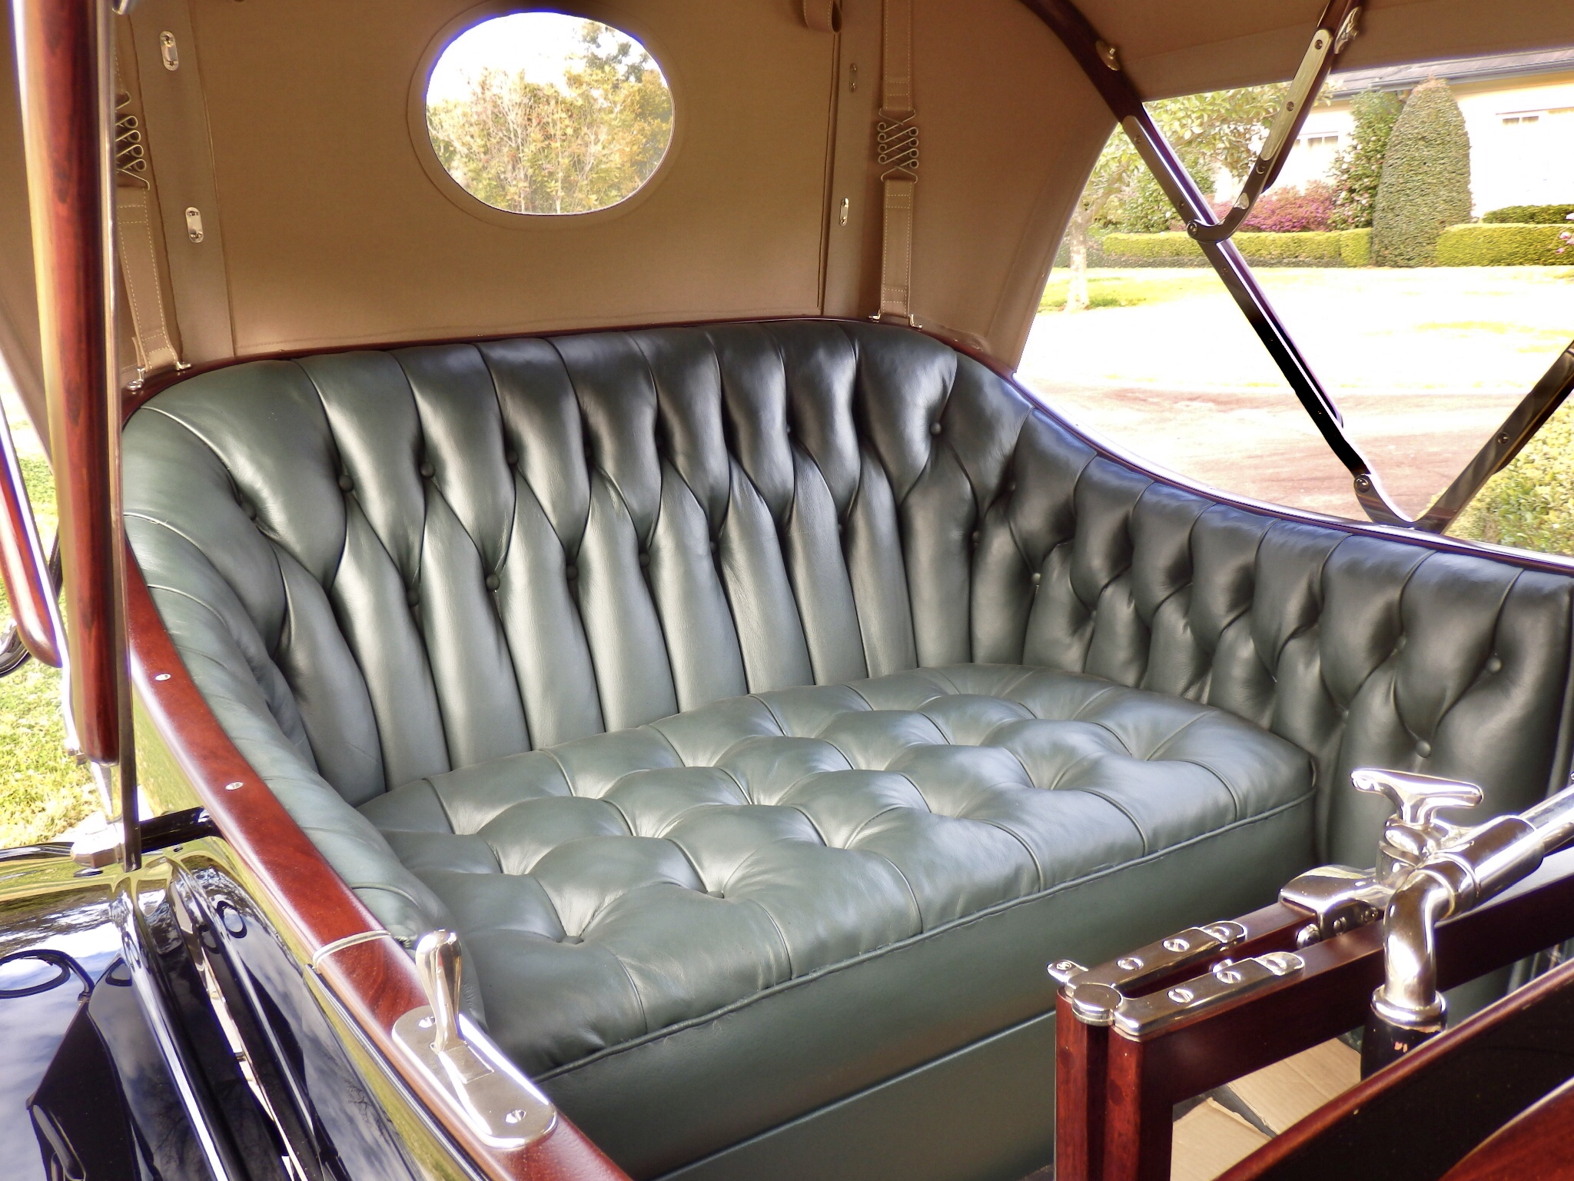

Finding someone in Australia to produce deep buttoned upholstery was not easy.

Winning Best of Show at the 2017 Melbourne MotorClassica was a highlight of my career.

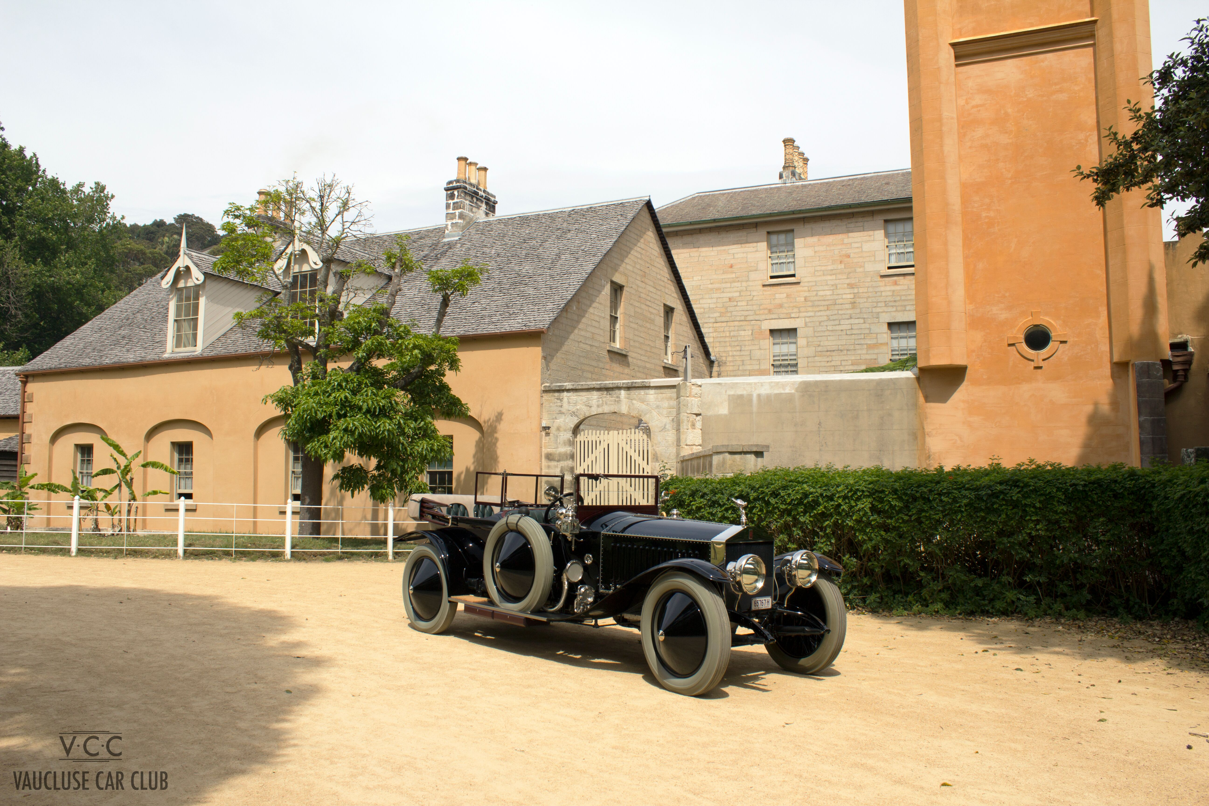

Wonderful historic setting at Wentworth House, Vaucluse.

